Determining the Cleanest Method to Consume a Cheeseburger to Reduce Waste

Student Names

Kettering University

Author Note

This senior thesis is submitted as partial fulfillment of the graduation requirements of Kettering University needed to obtain a Bachelor of Science in Mechanical Engineering. The conclusions and opinions expressed in this thesis are from myself and do not necessarily represent the position of Kettering University or anyone else affiliated with this culminating undergraduate experience. Although this thesis represents the compilation of my own efforts, I would like to acknowledge and extend my sincere gratitude to the following individuals for their valuable time and assistance, without whom the completion of this thesis would not have been possible: staff of Five Guys at Miller Road, for their immense help supplying the test material for this project and Johanna Brown, professor at Kettering University for her assistance in completing the final report of this study.

Abstract

The cleanest and most optimal methods of eating fast-food cheeseburgers has been the topic of extensive debate. Research conducted for this study found information pertaining to the construction of ideal burgers, the history of the cheeseburger, previous studies researching the same topic, and common costs to the customer and fast food restaurants that follow cheeseburger purchases. This experiment focused on the methods of eating cheeseburgers. Eight methods of consumption were tested then ranked (1 to 10) using the following criteria: bun slip, soil on fingers and napkin, time taken to wash hands, condiments dropped, and user experience. The participants were also encouraged to make comments or concerns regarding their method of consumption. The results from this research experiment were successful in determining the optimal method of eating a standard Five-Guys Cheeseburger according to the test criteria, which is the half-wrapped method. These findings will benefit fast food companies having the knowledge and confidence to promote this method to their customers to reduce costs on such things as napkins and cleaning costs. The limitations of this study were mainly the limited number of test iterations and the sample size. It would be ideal to test each method for a multitude of iterations and to expand burger types and makers for more comprehensive results using statistical analysis.

*Keywords*: Burger, Messy, Five-Guys, Cheeseburgers, Napkins, Clean, Cost reduction, Waste Reduction.

**Table of Contents**

Abstract 2

Introduction 4

Review of Literature 5

Conclusions & Recommendations 7

Methods of Research 8

References 14

Appendix A 15

**List of Illustrations**

Table 1:Rating Scale ……………………………………………………………………11

Table 2: Testing Results ………………………………………………………………...12

Determining the Cleanest Method to Consume a Cheeseburger to Reduce Waste

The purpose of the project is to combat the inherent messiness involved in eating a cheeseburger by researching and testing various methods that can be used to eat a burger. The problem with messy cheeseburgers is there is a lot of waste involved, for instance this could be the toppings lost during consumption of the burger or napkins used to clean up the mess made. The objective of this project is to provide burger places with information to teach their customers how to consume the messiest of burgers as cleanly as possible, to in return save the establishment money by reducing the amount of waste. This study will focus on a well-known messy cheeseburger, the Five-Guys (double patty) cheeseburger with the standard included toppings (see Figure 1). By using a widely attainable standard of a messy cheeseburger this project can be easily recreated. The burger establishments will benefit by decreasing the waste of napkins and potentially effort and time required to clean tables.

The primary research was conducted by having four participants consume two cheeseburgers each, with explicit instructions as to how they had to eat. A total of eight methods were tested and rated by the following criteria: bun slip (see Figure 4), soil on fingers and napkin, condiments dropped, time taken to wash hands, and user frustration. The participants were not allowed to pick up any condiments or pieces of the burgers if they fell off. The secondary research conducted was used to pick the eight methods used for testing, and the technique with the biggest impact for the burger establishments would be considered the best. The research resulted in the one clear best method to eating a burger, but many of the rest were very closely rated. For burger establishments to reduce waste they need to inform their customers that the cleanest way to eat a burger is by keeping the burger half wrapped while eating. The limitations of the study would be that only one iteration of each method was tested, by testing multiple times the data may have had a better spread or a clearer ranking of the best versus the worst methods.

# Review of Literature

Modern day hamburgers have come a long way from their earliest form in 1200 BC. This early form was composed of ground lamb or mutton formed into a patty that had been tenderized between a horse’s back and their saddle. It was then was consumed raw one-handed while riding. From then it developed into a hamburg steak, which was low grade beef ground and seasoned with regional spices served cooked or raw. First glimpses of modern hamburgers were seen in 1885 when a man who owned a meatball stand changed his product to fit his market. Customers wanted something easy to eat while walking around the county fair, so he flattened his meatballs into patties and served them between two slices of bread. Around 1916 is where we see a transition to ground beef served on a specially made bun: the inventor moved on to open White Castle. Shortly after this time, more toppings were added to burgers, including cheese. These various toppings can result in a dirtied customer, so modern fast food corporations have invested time and effort to optimize customer eating experiences and revenue.

Soiled fingers, stains, and napkins are often associated with the modern fast food experience. The cost of cleanup is a costly concern for chain restaurants trying to increase profits. In, 2015, the Environmental Protection Agency conducted a study found U.S. consumers use an average of 3 paper napkins per meal. This results in the staggering figure that each American uses an average of 2,200 napkins annually. The EPA concluded that an estimated 315 million Americans collectively used 693 billion napkins per year (Dempsey Uniform & Linen Supply). This level of consumption is costly financially, but also environmentally. According to waste statistics from *Greenlivingtips.com*, the pulp and paper industry is the single largest consumer of water in Organization for Econ Cooperation and Development (OECD) countries and the third largest greenhouse gas emitter. These facts have not gone unnoticed by fast food corporations and their investors.

McDonald’s, one of the largest franchise restaurants in existence, has made it a point to reduce their environmental impact. They address this on their corporate website saying, “By 2025, the World Bank estimates a staggering 6 million tons of waste will be produced each day. When you operate over 37,000 restaurants in more than 100 countries serving 69 million people each day, even small changes can make a big difference” (McDonald’s, 2019). This motivation most likely originates from reducing increasing costs in today’s economy and from their investors. In a report published on *Greenbiz.com*, a group of investors managing over $6.5 trillion dollars called upon six of the largest fast food companies to address their carbon footprint and water use. Industry, investors, and the public are looking for quantifiable and directed change towards more sustainable practices. A small step in that direction, specifically for American style fast food restaurants, is reducing the cleanup necessary after eating a handheld meal. One solution method starts from the very beginning: holding the burger.

A group of Japanese scientists composed of a dentist, an engineer, and an expert in fluid mechanics analyzed optimal methods of holding and eating a hamburger. By generating a 3D scan of the burger, they analyzed particle interactions of a burger being held in various configurations. The typical holding method of index, middle, ring, and pinkies placed on the top bun with thumbs lifting from the bottom results in condiments spilling out of the burger. After analysis, they concluded that holding the burger with thumbs and pinkies on the bottom bun and index, middle, and ring fingers on the top bun is the most optimal method. This method distributed loading on the burger resulting in the least amount of spillage. They also recommended not holding too tight to avoid risk of spillage (Ashcraft, 2014). It is said that by eating a burger using this method, it will significantly reduce the amount of supplies and time necessary for cleaning after eating which will lower costs in fast food restaurants.

## Conclusions & Recommendations

After analysis, the cleanest method in which to consume a standard Five-Guys cheeseburger is with the half-wrapped method. The messiness during and after eating were minimal compared to the other consumption methods resulting in less napkin usage, less time taken washing hands, less toppings dropped, and increased ease of use. Keeping a burger wrapped contains its contents into a tight package, reducing spillage and soil on fingers. This method benefits both fast-food companies and consumers by reducing cleaning after eating. By reducing napkin usage and cleaning necessary per meal, it will reduce costs to large fast-food companies and increase customer satisfaction.

Based on the research conducted, several improvements and changes are recommended. The study is subjective, but that does not eliminate the necessity for data. A more comprehensive study can be created by expanding the sample size via two methods: increasing test iterations for each method and expanding the data set to include different restaurants and sandwiches. Increasing test iterations will result in a more complete statistical analysis and more clearly rank alternative methods. By expanding the types and creators of burgers, even other sandwiches, a generalized method may be determined for eating *sandwiches* and not exclusively burgers. It is also recommended that more testing criteria be included to spread comparison data between methods for greater context and understanding of results. By expanding the data sample, more concise and useful conclusions can be drawn from this study.

### Methods of Research

#### Purpose

The method of research for this study is primarily composed of observation/participant observation and surveys. The purpose of this study is to compare the methods of eating cheeseburgers according to participants to determine the most user-friendly method for eating burgers for optimal enjoyment and least amount of cleaning. The subjective nature of this study is necessary because the goal is to gauge the most user-friendly method which depends entirely on the participants observations. The scope of the study is limited, but it will give quantifiable results of user experience.

##### **Test Description**

The Cheeseburger from the Five Guys restaurant in Flint, Michigan was determined to be the optimal choice for data collection because of its well-known messiness and size. Eight eating methods were tested by this study, in total. These cheeseburgers are described as “Two slices of Kraft American Cheese melted between two freshly grilled patties on a soft, toasted bun,” from the Five Guys online menu. Each of the burgers were ordered at the same time and made by the same chef so they were consistent and repeatable so that the tests could be conducted with accurate, representative, and repeatable results. As shown in the photographs below, each burger contained all the same ingredients. The methods of eating the burgers were compared using the comparison criteria.

##### **Criteria**

Eight cheeseburgers were eaten by four consenting participants comparing eight different consumption methods: eaten with a single tooth-pick down the middle, eaten the standard method (thumbs on bottom bun and rest of fingers on top bun), eaten half-wrapped, eaten cut in half, eaten with thumbs and pinkies supporting bottom bun and rest of fingers on top (see Figure 2 for an example), eaten one handed, eaten with fork and knife, and eaten upside down. These methods were compared using five relevant criteria: bun slip, soil on fingers and napkin, condiments dropped, time taken to wash hands, and user frustration. Bun slip was defined by the amount of displacement between the top and bottom bun. Soil on fingers and napkins was defined as being the amount of grease and condiments left on the hands and wiped on the napkins. Condiments dropped would be a simple count of how many dropped items from the burger there were. Time taken to wash hands was decided to be a user satisfaction rating rather than the actual wash time itself. In other words, the user was asked to rate how difficult it was to remove soil from their hands. This would prove more beneficial to the judgment of the best method. The criterion of user frustration was a rating like time taken to wash hands. It was based on how difficult the burger was to truly enjoy. These criteria of judgment were gauged on a subjective rating scale of one to ten, with one being the most optimal and ten being the least optimal. By summing these values, the method of consumption with the lowest total should be the most optimal method to eat a cheeseburger. The eaters were also given the opportunity to add additional comments to their ratings for extra possible clarity of judgment.

##### **Materials**

8 cheeseburgers with:

* 2 patties
* 2 slices cheese
* 1 bun
* Lettuce
* Pickles
* Tomatoes
* Grilled onions
* Mustard
* Ketchup

Soil measurement instruments:

* 4 plates
* 8 napkins
* 2 forks
* 2 knives
* 1 toothpick
* Soap
* Water
* Sink

##### **Participants**

The test was performed by four participants. The participants were all male Kettering University students. Participant 1 had the most burger eating experience, with participant 2 slightly less experienced. Participant 3 had an average level of experience eating burgers, and Participant 4 had a limited experience.

##### **Procedure**

To test each of the eight different consumption methods, the burgers were first acquired and prepared accordingly for the eight different methods: the first had a tooth-pick inserted vertically into the top bun; the second was left half wrapped, the third was cut in half, and the subsequent burgers were not altered. Excluding the half-wrapped burger, all burgers were first unwrapped and placed on a plate to be eaten according to the eight test methods, which can be found in Table 2. The “Toothpick” method used the burger with the inserted toothpick, which was eaten radially. The “Half-Wrapped” method was eaten using the burger prepared half-wrapped, with the participant eating with fingers touching only the wrapper. The “Control” is the standard method, which consists of the participants thumbs being placed on the bottom bun with the rest of fingers on the top bun. The “Cut in Half” method requires the burger be cut in half, with each side being eaten with the “Control” method. The “Pinkies and Thumbs” method consisted of using the thumbs and pinkies to support the rear and bottom bun with the rest of the fingers on top. The participant testing the “One Handed” method used exclusively one hand to eat, simulating eating with fries or driving. The participant testing the “Fork and Knife” method ate cutting one bite sized piece off at a time. The “Flipped” method utilized the “Control” with the exception of the thumbs being placed on the top bun and the rest of the fingers placed on the bottom bun.

Each participant was given their burger and one napkin to use. Participants were then instructed to eat with the designated method without setting the burger down to rule out any issues with picking up a half-eaten burger. They were also instructed to use the designated napkin to wipe their fingers if necessary. Once each burger was consumed, the amount of condiments left on the plate, soilage on the napkin, and the time taken to wash hands was noted. After participants finished cleaning up, they were asked to rate the methods using the Rating Scale found in Table 1.

Table 1

*Rating Scale:* Participants were asked to rank their experience for each category on a 1-10 scale

|  |  |
| --- | --- |
| **Difficulty:** | **Rating Number:** |
| Minimum | 1 |
|  | 2 |
|  | 3 |
|  | 4 |
|  | 5 |
|  | 6 |
|  | 7 |
|  | 8 |
|  | 9 |
| Maximum | 10 |

##### **Results & Discussion**

Out of the eight tested methods, the spread of data was not very large, with six of the eight methods scoring within four data points of each other. See Table 2 below for details.

Table 2

*Testing Results*: The results for each of the eight methods are listed by category.

|  |  |  |  |  |  |  |  |
| --- | --- | --- | --- | --- | --- | --- | --- |
| **Methods** | **Bun Slip** | **Soil on Fingers**  **and Napkin** | **Time Taken to Wash Hands** | **Condiments Dropped** | **User Experience** | **Comments** | **Sum:** |
| **Tooth-pick** | 3 | 4 | 5 | 6 | 2 | - Eaten Radially | 20 |
| **Half-Wrapped** | 1 | 1 | 3 | 1 | 3 |  | 9 |
| **Control** | 4 | 5 | 6 | 2 | 4 |  | 21 |
| **Cut in Half** | 3 | 3 | 5 | 3 | 3 | - Started from center  - Felt like control burger | 17 |
| **Pinkies and Thumbs** | 2 | 3 | 7 | 2 | 2 |  | 16 |
| **One Handed** | 8 | 2 | 7 | 7 | 1 | - Bun starts to droop early on | 25 |
| **Fork and Knife** | 8 | 1 | 2 | 7 | 1 |  | 19 |
| **Flipped** | 5 | 4 | 5 | 2 | 3 |  | 19 |
| **Median Score** | 3.5 | 3 | 5 | 2.5 | 2.5 |  | 19 |

The results from this research experiment were successful in determining the optimal method of eating a standard Five-Guys Cheeseburger, which is the half-wrapped method. The next two best methods being, supported from back with pinkies, and cut in half. A common problem noted the participants was that the last few bites of the burger became too small to eat cleanly. Bun slippage became too extreme to handle, and the burger would tend to fall apart at this time.

Some of the limitations of this study would be small number of participants in the study, as well as the limited criteria evaluated. The contributing factor as to why the small sample size could have produced limitations and difficulties in selecting the optimal method for eating the standard Five-Guys Cheeseburger was the lack of repeated tests for each method. In addition to the small sample size, having a limited number of criteria to evaluate could contribute to skewed data because not all aspects of burger consumption were considered.

References

Ashcraft, B., & Ashcraft, B. (2014, January 31). The Perfect Way to Hold a Hamburger, Proven

by Science. Retrieved February 25, 2019, from https://kotaku.com/the-perfect-way-to-hold-a-hamburger-proven-by-science-1513085238

Bloch, M. (2018, October 27). Fast facts - consumption statistics. Retrieved March 12, 2019,

from <https://www.greenlivingtips.com/articles/Consumption-statistics.html>

Cuff, M. (2019, January 31). A lot on their plate: Investors turn heat up on global food giants

McDonald's, Restaurant Brands International and Yum! Brands. Retrieved March 12, 2019, from [https://www.greenbiz.com/article/lot-their-plate-investors-turn-heat-global-food-giants-mcdona](https://www.greenbiz.com/article/lot-their-plate-investors-turn-heat-global-food-giants-mcdonal)lds-restaurant-brands

Dempsey Uniform & Linen Supply. (n.d.). *Paper vs. Cloth: Just the Facts* [Brochure]. Author.

Retrieved March 15, 2019, from [http://www.dempseyuniform.com/Portals/0/PDF/ Brochure_](http://www.dempseyuniform.com/Portals/0/PDF/%20Brochure_)PaperVsClothFacts.pdf

Menu. (n.d.). Retrieved February 25, 2019, from http://www.fiveguys.com/Menu

Packaging and Recycling | McDonald's. (n.d.). Retrieved March 12, 2019, from

<https://corporate.mcdonalds.com/corpmcd/scale-for-good/packaging-and-recycling.html>

Stradley, L. (2016, December 21). History of Hamburgers, What's Cooking America. Retrieved

February 25, 2019, from https://whatscookingamerica.net/History/HamburgerHistory.htm

Appendix A

Figure 1

*Standard Five-Guys Cheeseburger*

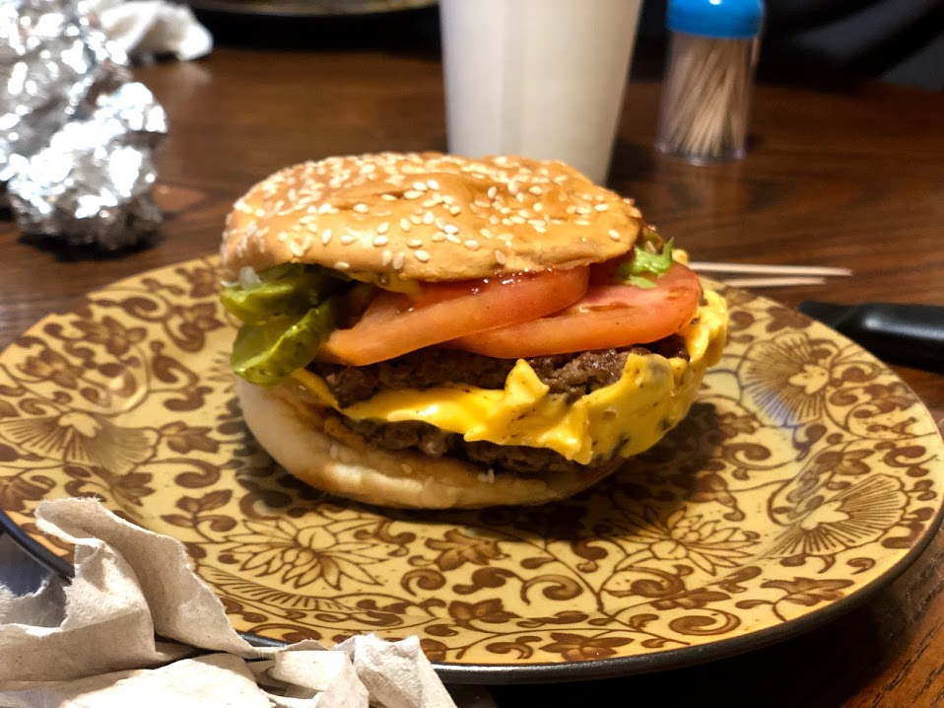

Figure 2

*Example method withe the thumbs and pinkies on bottom bun and rest of fingers on top*

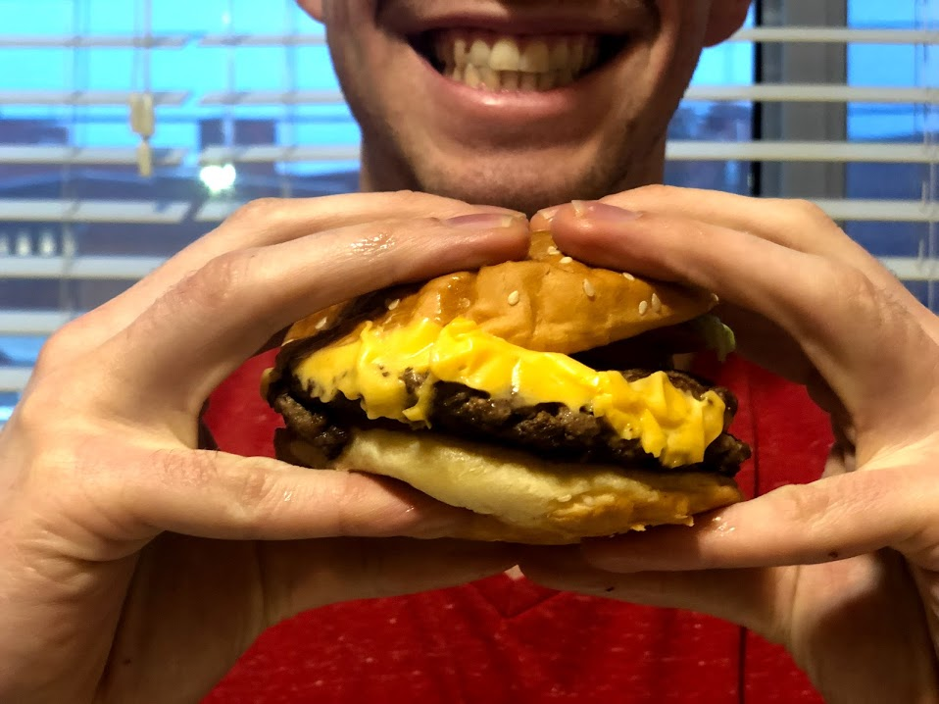

Figure 3

*Example of burger eaten cut in half*

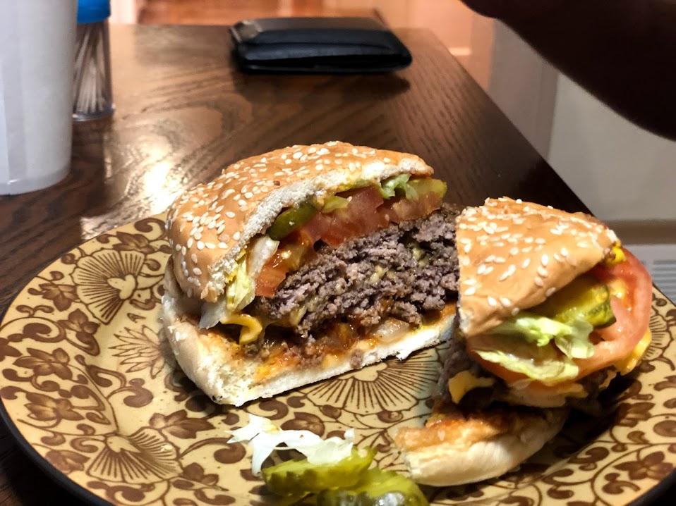

Figure 4

*Example of extreme bun slip*

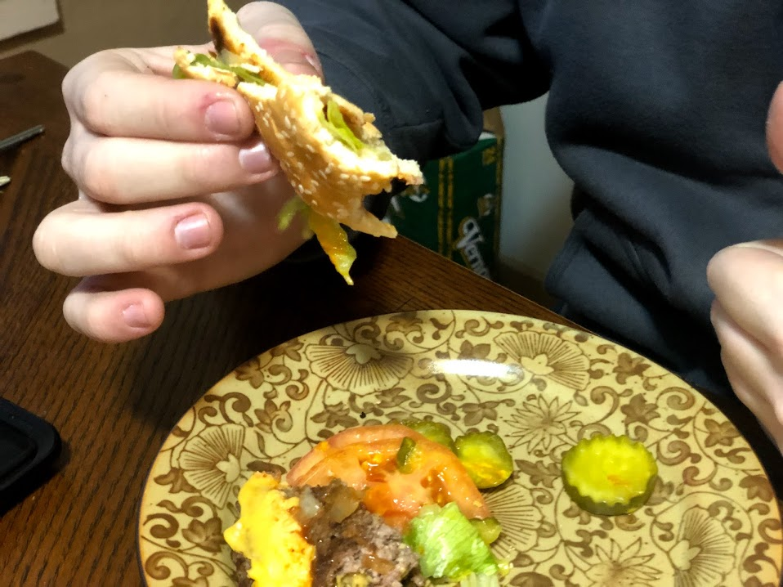

Figure 5

*Example of spillage of condiments onto the plate*

